Answer the following questions in your own words. You may use your textbook reading and/or ancillary sources.

- Explain each of the following scenarios in the physics lab. Draw free-body diagrams for all three events.
B1. A cart is at rest on a. horizontal track, and b. inclined track.

a.
F_{Normaled}

Object
F_{applied}
F_{friction}

F_{Gravitationaled}

F_{friction =} u * Fnormal ; note u= coefficient of friction between the object and horizontal track
F_{applied =} Force applied to the object by person or another object
F_{gravitational =} m * g ; m= mass and g= 9.8 N/ kg
F_{normal =} Force exerted perpendicular to the object . In this scenario Fnormal and Fgravitational has same value

F_{normal}
Tension or Friction

b.
Object

mg Cos α
mg sin α _{ed}

mg _{ed}

α

m= mass
α = angle of inclined plane
g= gravitation pull

B2. A cart is in motion for 10 seconds on a horizontal track after an impulse is given.

F_{Normaled}

Cart
F_{applieed}
F_{friction}

F_{Gravitationaled}

F_{friction =} u * Fnormal ; note u= coefficient of friction between the object and horizontal track + Air resistance
F_{applied =} m*a ; m= mass and a= acceleration ,
acceleration = $\frac{Change on Velocity }{time }$
F_{gravitational =} m * g ; m= mass and g= 9.8 N/ kg
F_{normal =} Force exerted perpendicular to the object . In this scenario Fnormal and Fgravitational has same valu

B3. A cart is in motion for 10 seconds on an inclined track after released.

Tension or Friction
F_{normal}

b.
Object

mg Cos α
mg sin α + a_{ed}
mg _{ed}

α

m= mass
α = angle of inclined plane
g= gravitation pull

B4. A friction cart rests on an inclined track.
F_{normal}
Tension or Friction

b.
Cart

mg Cos α
mg sin α _{ed}

mg _{ed}

α

F_{friction =} m * g *Cos α * u

M= mass
G= gravicational pull
Α = angle
U = coefficient of friction between the cart and inclined plane

B5. A fan-frictionless cart system with fan running accelerates on the horizontal track.

Acceleration Friction
F_{normal}

b.
Object

mg Cos α

mg sin α + Friction _{ed}
mg _{ed}

α

Note: The acceleration may varies in direction . upward or downward

- Explain the properties of the following physical quantities: distance travelled, displacement, average speed, average velocity and instantaneous velocity and acceleration.

Distance travelled
- The total length travelled between two point a to b (two positions)
Displacement
- It’s a vector quantity which is the change in position of an object

Average speed
- Total distance traveled divided by total time elapsed
Average Velocity
- Vector Quantity. Change in position or displacement divided by time intervals
Instantaneous Velocity
- The quantity how fast an object is moving anywhere along its path
Instantaneous acceleration
- Continuous function of time and gives the acceleration at any specific time during the motion

- A metal ball of 20 Kg. mass is released from a 20 m. high building. Explain the physical properties of the event using the physical quantities you explained in the previous question.

F_{downwarded}

F_{upwarded}

F_{downward}= Mass * acceleration ( gravitational pull )
F_{upward}= Air resistance ( Friction )

- What is a force? What does a force do? How do you know that a force exists?
- Force is push or pull upon an object resulting from the objects interaction with other object

- What is a vector?
- Quantity that has both magnitude and direction . It is typically represented by arrow whose direction is the same as the quantity and whose length is proportional to the quantity’s magnitude

- Express the following vectors in rectangular notation.
(a) A = (3.00, 25.0°)

Real component = 5( cos 25) = 2.71
Imaginary component = 5 ( sin 25 )= 1.26

Rectangular form = 2.71 + 1.26j
(b) B = (17.0, -135°)

Real component = 17( cos 45) = -12.02
Imaginary component = 17 ( sin 45)= 12.02
Rectangular form = 12.02 + 12.02j

- A cannon aims a ball into a haystack. Explain the trajectory for different angles is 30°, 45° and 60°.

The cannonball launched at a 45-degree angle had the greatest range. The cannonball launched at a 60-degree angle had the highest peak height before falling. The cannonball launched at the 30-degree angle reached the ground first.

- Write Newton’s 1st, 2nd and 3rd laws in the form of equations (mathematical representation) and explain their meaning in your own words (language representation).

1St law of motion ( law of inertia )
- If an object is at rest , it will stay at rest unless there is force acts on it
- An object in motion will remain in motion unless net force acts on it
- Σ F = 0 \Sigma F=0 ΣF=0\Sigma, F, equals, 0
2nd law of motion ( Law of acceleration )
- predicts the behavior of objects for which all existing forces are balanced
- F=ma ; Mass * acceleration
3rd law of motion ( law of action and interaction )
- when two bodies interact, they apply forces to one another that are equal in magnitude and opposite in direction
- F_{a}=-F_{b}

- Explain your understanding of elastic and inelastic collisions.

Elastic collision
- collision in which there is no net loss in kinetic energy in the system as a result of the collision. Both momentum and kinetic energy are conserved quantities in elastic collisions
Inelastic Collision
- s a collision in which kinetic energy is not conserved due to the action of internal friction.
- In collisions of macroscopic bodies, some kinetic energy is turned into vibrational energy of the atoms, causing a heating effect, and the bodies are deformed

- What is your understanding of the conservation of momentum?
- general law of physics according to which the quantity called momentum that characterizes motion never changes in an isolated collection of objects; that is, the total momentum of a system remains constant. Momentum is equal to the mass of an object multiplied by its velocity and is equivalent to the force required to bring the object to a stop in a unit length of time
- What shape is the strongest for building bridges? Explain.
- The overall shape of many bridges is in the shape of a catenary curve. The catenary curve is the strongest shape for an arch which supports only its own shape. Freely hanging cables naturally form a catenary curve.

- What is friction?
- the resistance that one surface or object encounters when moving over another.

- What forces are responsible for keeping the objects moving in a circular path in the above experiments?
- Centripetal force is net force that acts on object to keep it moving along circular path

- What is the difference between rotation and circular motion?
- In circular motion, the object moves in circle with specific height or radius ( example satellite) . Rotational motion rotates in axis ( example : Earth )
- What is the difference between torque and force?
- Torque is a type of force that is applied to an object which results in the object rotating around an axis. Force is an action that causes a change in the motion of an object.

Part 2
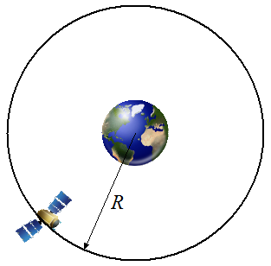
Problem # 7
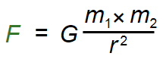
A geostationary orbit is a circular orbit above the earth's equator. An object in such an orbit has an orbital period equal to the earth's rotational period, and therefore appears motionless in the sky relative to ground observers. This is useful for communication and weather satellites since antennas on earth do not have to track them and instead are pointed in a permanent direction at the orbiting satellites.
Using Newton's Law of Gravitational Attraction, a mass of earth equal to 5.9736 × 10²⁴ kg, and an orbital period of 23 hours, 56 minutes, 4.0916 seconds, calculate the radius R of a geostationary orbit around the earth. (Answer: 42164 km) G = 6.673 x 10⁻¹¹ N m²/kg²
Given :
G = 6.673 x 10⁻¹¹ N m²/kg²
M = 5.9736 × 10²⁴ kg
T = 23 hours, 56 minutes, 4.0916 seconds
Required: Radius of geostationary orbit around the Earth ( R )

Solution :
V= $\frac{2 * pi* R}{T}$
V= Sqrt ( GM/R)

Equating both velocity to get R
R = [GMT² / 4*pi²]^{1/3}
R = 4.2 x 10⁴ km

Problem # 8
A block sits on an inclined plane. Draw the free-body diagram. What magnitude force do you need to push the block to prevent from sliding down? What force do you need to push to make the block start moving up the inclined?

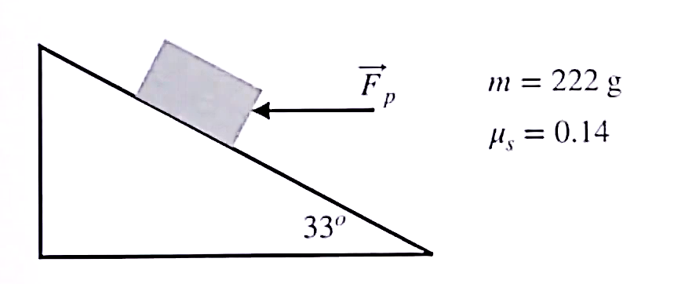
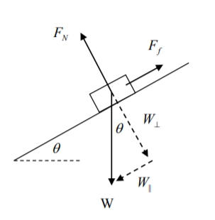

W = mg =(0.222) *9.8 = 2.17 N
W( parallel )=mg sin theta = 0.222 * 9.8 sin 33 = 1.18 N
W ( perpendicular ) = mg cos theta = 0.222 * 9.8 cos 33 = 1.82 N

Force needed to start moving up = 1.18 Newtons

Problem # 9
Find the tension on each of the cables: Tab, Tad and Tac. Draw the free-body diagram.

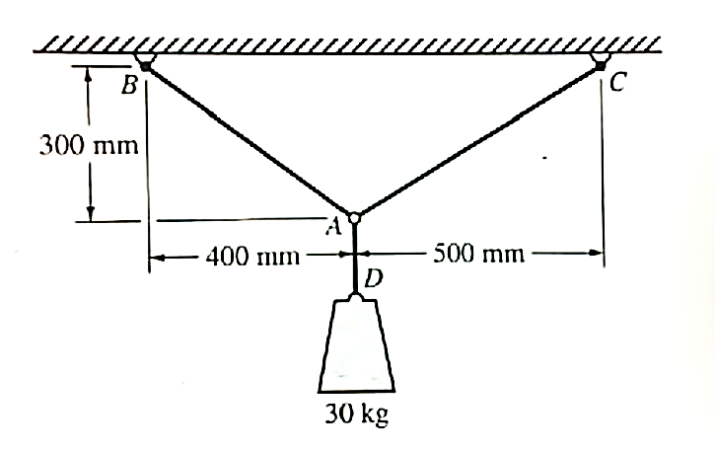
Note : Cannot solve the tension since there is no angle between the tensions

FBD :
Td
Tc

Ta
F=mg : 30kg * 9.8m/s

Problem # 10
A 2600 kg SUV traveling west at 15 m/s collides head on with a 1300 kg sedan traveling east at 20 m/s. Determine the speed and direction of the two cars immediately after impact if they lock together.

m1 = 2600kg
u1 = 15m/s
m2 = 1300kg
u2 = -20m/s [as it is moving in opposite direction]
here, after impact, cars lock with each other so v (final velocity) is the same for both cars, i.e., v1 = v2
we know,
m1u1+m2u2 = m1v1+m2v2 [Law of conservation of momentum]
(2600)(15)+(1300)(-20) = (2600)v1+(1300)v2
39000-26000 = (2600+1300)v1 [as v1 = v2]
v1 = 13000/3900
v1 = 3.33 m/s
Here, m1v1 = 2600x3.33 = 8658kgm/s
m2v2 = 1300x3.33 = 4329kgm/s
as final momentum of car 1 is higher than that of car 2, both cars will move in direction of car1, that is, west direction.

Problem # 11
Calculate the bicep tension force. ( I can give you the link because its hard to type and put the full solution )
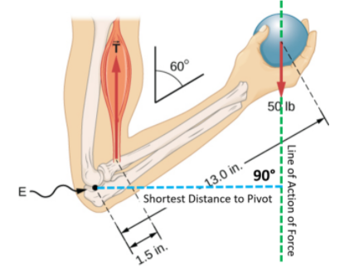

We identify three forces acting on the forearm: the unknown force F⃗ at the elbow; the unknown tension T⃗ M in the muscle; and the weight w⃗ with magnitude w = 50 lb. We adopt the frame of reference with the x-axis along the forearm and the pivot at the elbow. The vertical direction is the direction of the weight, which is the same as the direction of the upper arm. The x-axis makes an angle β = 60° with the vertical. The y-axis is perpendicular to the x-axis. Now we set up the free-body diagram for the forearm. First, we draw the axes, the pivot, and the three vectors representing the three identified forces. Then we locate the angle β and represent each force by its x- and y-components, remembering to cross out the original force vector to avoid double counting. Finally, we label the forces and their lever arms. The free-body diagram for the forearm is shown. At this point, we are ready to set up equilibrium conditions for the forearm. Each force has x- and y-components; therefore, we have two equations for the first equilibrium condition, one equation for each component of the net force acting on the forearm.

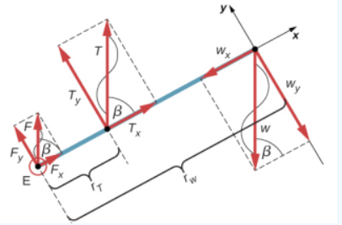
Notice that in our frame of reference, contributions to the second equilibrium condition (for torques) come only from the y-components of the forces because the x-components of the forces are all parallel to their lever arms, so that for any of them we have sin θ = 0 in For the y-components we have θ = ± 90° Also notice that the torque of the force at the elbow is zero because this force is attached at the pivot. So the contribution to the net torque comes only from the torques of Ty and of wy.

We see from the free-body diagram that the x-component of the net force satisfies the equation

+Fx+Tx−wx=0(12.3.6)
and the y-component of the net force satisfies

+Fy+Ty−wy=0.(12.3.7)
Equation 12.3.6 and Equation 12.3.7 are two equations of the first equilibrium condition (for forces). Next, we read from the free-body diagram that the net torque along the axis of rotation is

+rTTy−rwwy=0.(12.3.8)
Equation 12.3.8 is the second equilibrium condition (for torques) for the forearm. The free-body diagram shows that the lever arms are rT = 1.5 in. and rw = 13.0 in. At this point, we do not need to convert inches into SI units, because as long as these units are consistent in Equation 12.23, they cancel out. Using the free-body diagram again, we find the magnitudes of the component forces:

FxTxwxFyTywy=Fcosβ=Fcos60o=F2=Tcosβ=Tcos60o=T2=wcosβ=wcos60o=w2=Fsinβ=Fsin60o=F3–√2=Tsinβ=Tsin60o=T3–√2=wsinβ=wsin60o=w3–√2.

We substitute these magnitudes into Equation 12.3.6 , Equation 12.3.7 , and Equation 12.3.8 to obtain, respectively,

F2+T2−w2F3–√2+T3–√2−w3–√2rTT3–√2−rww3–√2=0=0=0.

When we simplify these equations, we see that we are left with only two independent equations for the two unknown force magnitudes, F and T, because Equation 12.3.6 for the x-component is equivalent to Equation 12.3.7 for the y-component. In this way, we obtain the first equilibrium condition for forces

F+T−w=0
and the second equilibrium condition for torques

rTT−rww=0.
The magnitude of tension in the muscle is obtained by solving Equation 12.3.10 :

T=rwrTw=frac13.01.5(50lb)=43313lb≃433.3lb.
The force at the elbow is obtained

F=w−T=50.0lb−433.3lb=−383.3lb.
The negative sign in the equation tells us that the actual force at the elbow is antiparallel to the working direction adopted for drawing the free-body diagram. In the final answer, we convert the forces into SI units of force. The answer is

F=383.3lb=383.3(4.448N)=1705Ndownward
T=433.3lb=433.3(4.448N)=1927Nupward

